ADDENDUM - U30P2,14 HAVE BEEN ADDED TO THIS REPORT. These signals are the inputs whereas U30p3/13 are the outputs after a receiver on the VATAC. (I confused signals DIG_IN1 with _DIG_IN1.
The following screen shots were taken on 06-10-23. Oscilloscope mode is selected in each case and the test calibration pulse is set “ON”. Config. file is that supplied from IDEAS. In this mode many of the signals were seen to just be dc levels. In this case the presence of a larger signal was looked for (which was not due to the injected calibration pulse) and where found this was given the label of COSMIC. Note that it has subsequently been seen that some signals (for example the trigger signals) due have activity, but because these are current signals then it appears as though these signals are inactive – be careful! The yellow trace in all cases is the analog output signal observed on the VATAC card.
All these signals are monitored at the VATAC using a test ASIC card as input.

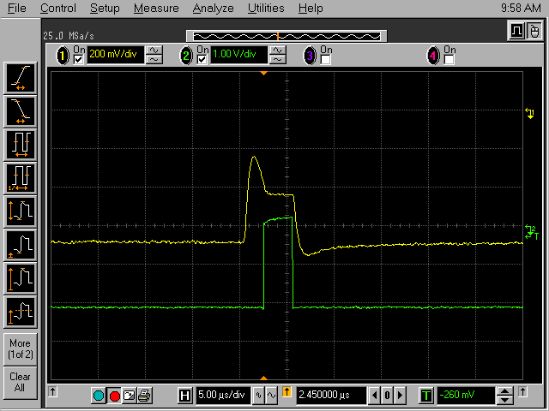
Figure 1 J38 (HOLD) VATAC - OSCILLOSCOPE MODE

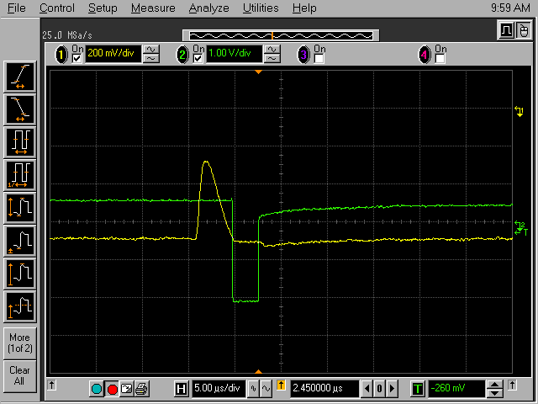
Figure 2 J39 (HOLDB)VATAC -OSCILLOSCOPE MODE

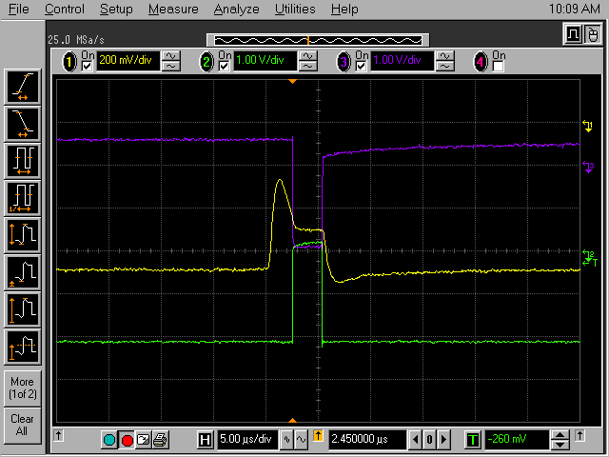
Figure 3 J39 -J38 (HOLDB (top trace) -HOLD) VATAC OSC MODE

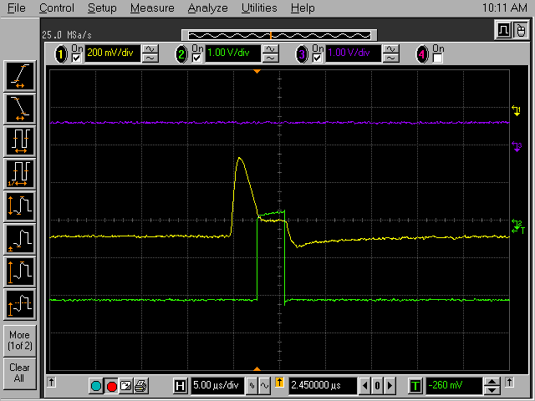
Figure 4 J39 - J32 (HOLD - CKB) VATAC OSC MODE
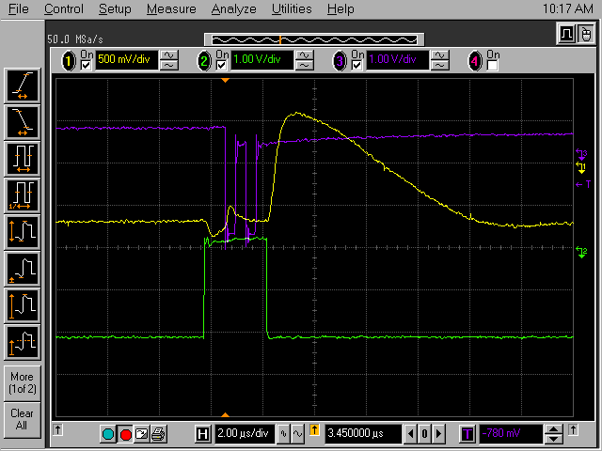
Figure 5 COSMIC J39 -J32 (HOLD - CKB) VATAC OSC MODE

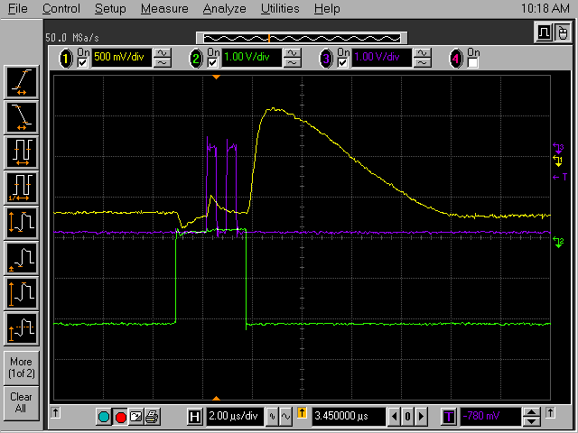
Figure 6 COSMIC J39 -J33 (HOLD - CK) VATAC OSC MODE

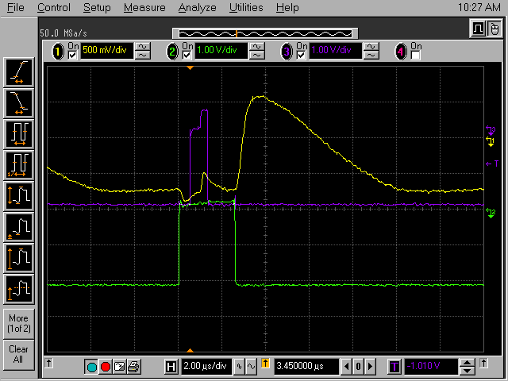
Figure 7 COSMIC J39 -J34 (HOLD-SHIFTIN) VATAC OSC MODE

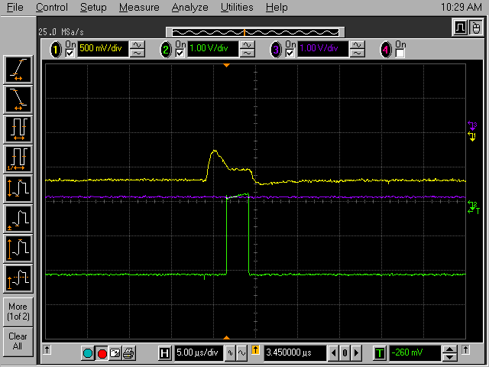
Figure 8 NO COSMIC J39 -J34 (HOLD-SHIFTIN) VATAC OSC MODE

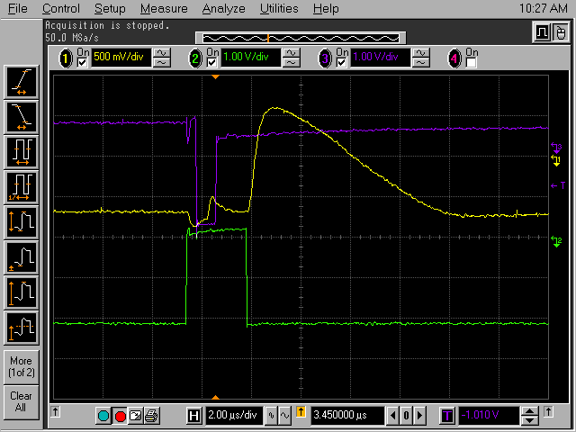
Figure 9 COSMIC J39 -J35 (HOLD-SHIFTINB) VATAC OSC MODE

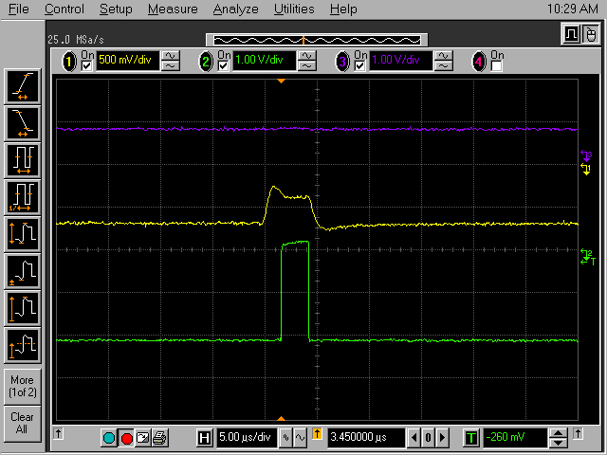
Figure 10 NO COSMIC J39 -J35 (HOLD-SHIFTINB) VATAC OSC MODE

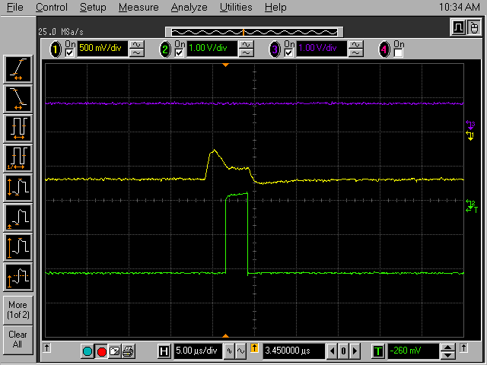
Figure 11 J39 –J44 (HOLD-CLKIN) VATAC OSC MODE

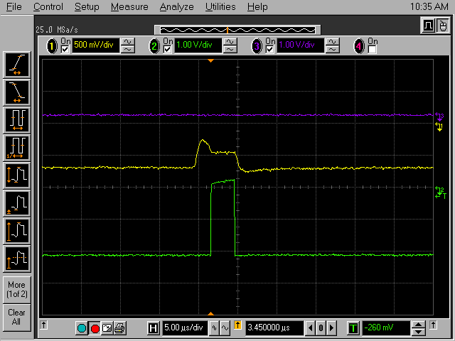
Figure 12 J39 –J45 (HOLD-REGIN) VATAC OSC MODE

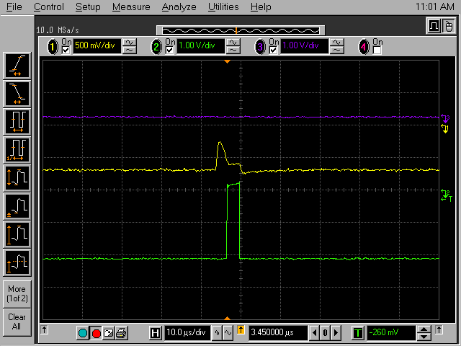
Figure 13 J39 –U30Pin3 (HOLD-REGOUT) VATAC OSC MODE

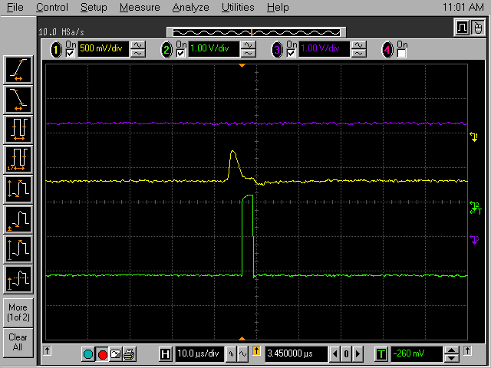
Figure 14 J39 –U30P13 (HOLD-SHIFTOUTB) VATAC OSC MODE

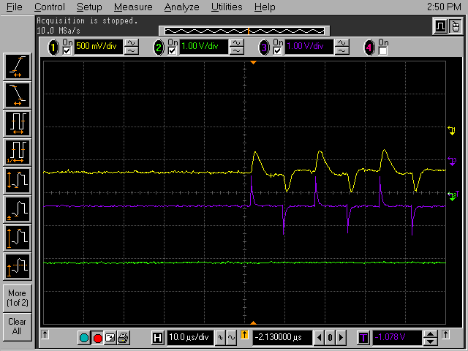
Figure 15 J39 –U30Pin2 (HOLD-REGOUT) VATAC OSC MODE

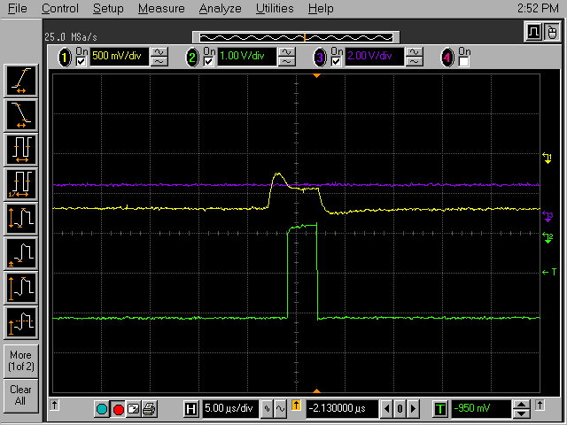
Figure 16 J39 –U30Pin14 (HOLD-SHIFTOUT) VATAC OSC MODE

