Noise and Pedestal Readout waveforms.

These waveforms are all taken at test points within the VATAC. Conditions of note: test off in asic mask download screen, cal pulse disabled in oscilloscope mode, trig source –internal, continuous in pedestal screen. Note – after quitting pedestal screen the continuous mode keeps running!! I found the only way to stop this so far is to quit the program! Take care on some of the x/y axis per division settings – some are “non-standard” values. Traces that look a little noisy have persistence mode on to highlight narrow pulses on a long timebase.

No activity was recorded on: J44 (CLKIN) J45 (REGIN)

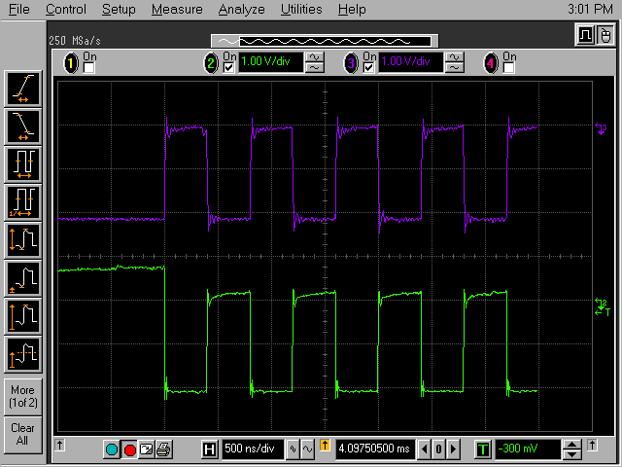
Figure 1 J32/J33 (CKB/CK) - 1

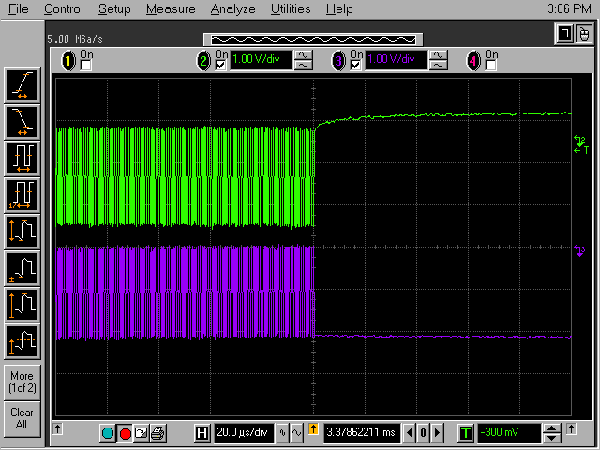
Figure 2 J32/J33 (CKB/CK) - 2
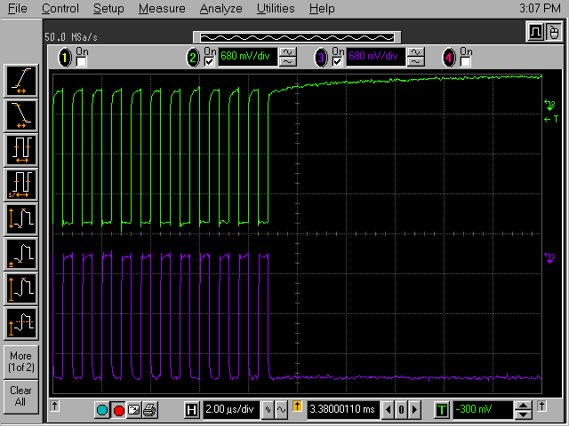
Figure 3 J32/J33 (CKB/CK) - 3

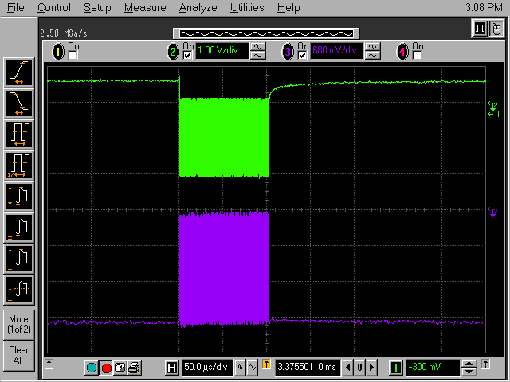
Figure 4 J32/J33 (CKB/CK) - 4

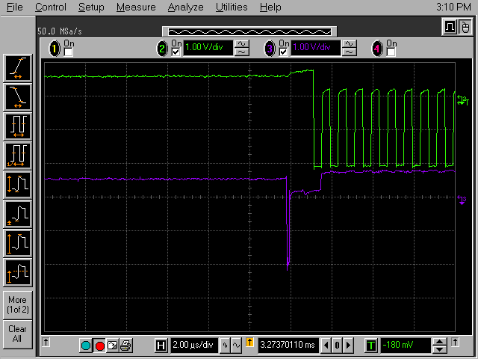
Figure 5 J32/J36 (CKB/DRESETB) - 1

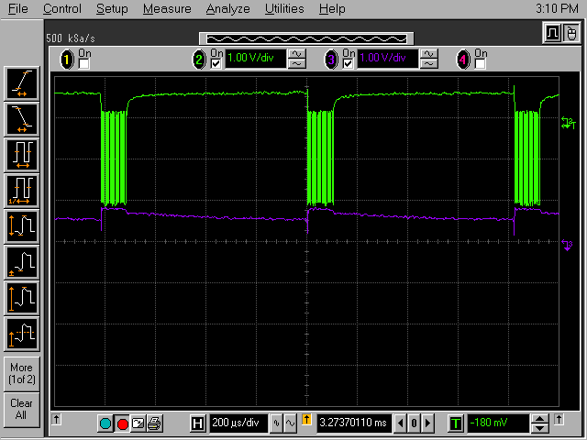
Figure 6 J32/J36 (CKB/DRESETB) - 2

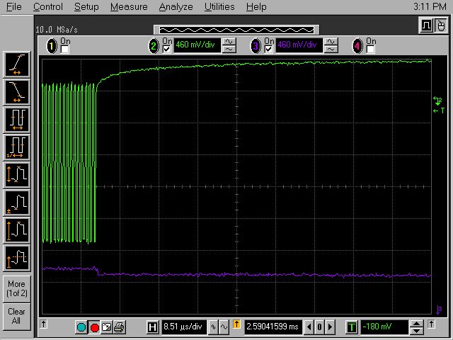
Figure 7 J32/J36 (CKB/DRESETB) - 3

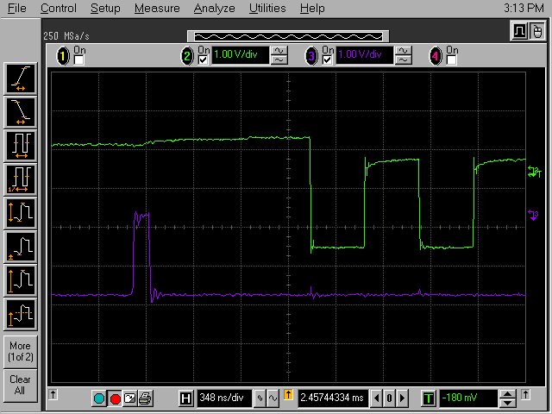
Figure 8 J32/J37 (CKB/DRESET) - 1

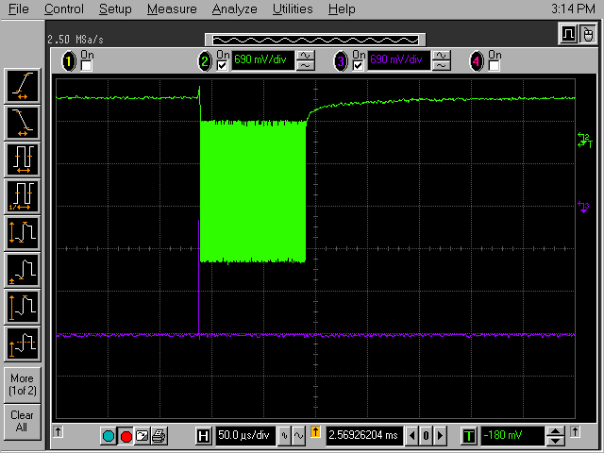
Figure 9 J32/J37 (CKB/DRESET) - 2

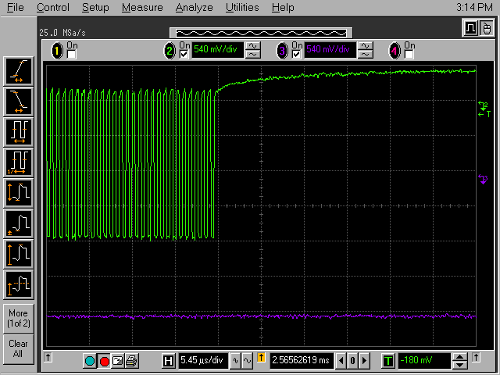
Figure 10 J32/J37 (CKB/DRESET) - 3

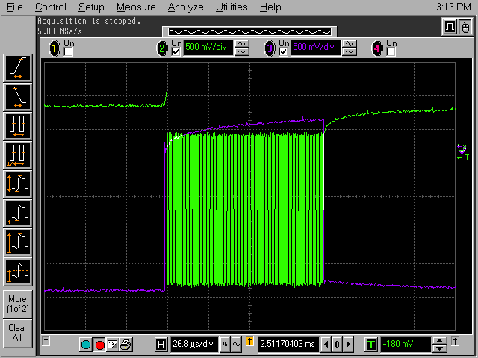
Figure 11 J32/J38 (CKB/HOLD) - 1

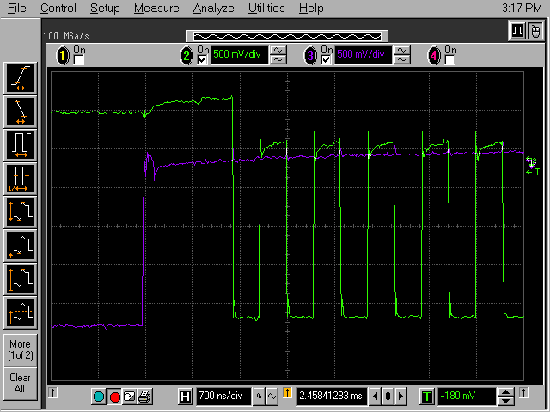
Figure 12 J32/J38 (CKB/HOLD) - 2

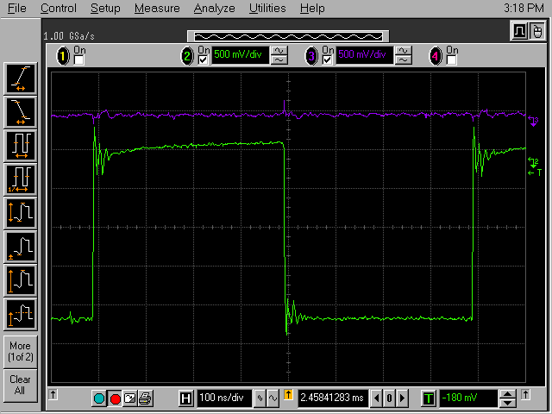
Figure 13 J32/J38 (CKB/HOLD) - 3 Just to see the glitch on the hold caused by the clock.

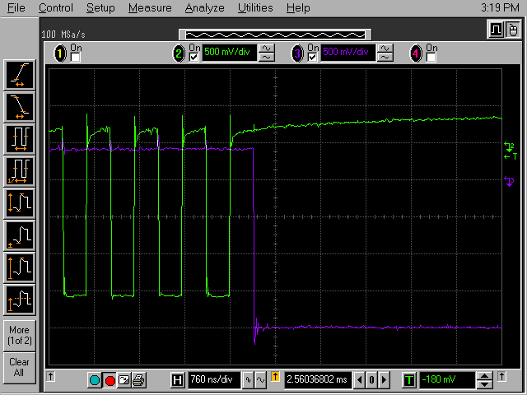
Figure 14 J32/J38 (CKB/HOLD) - 4

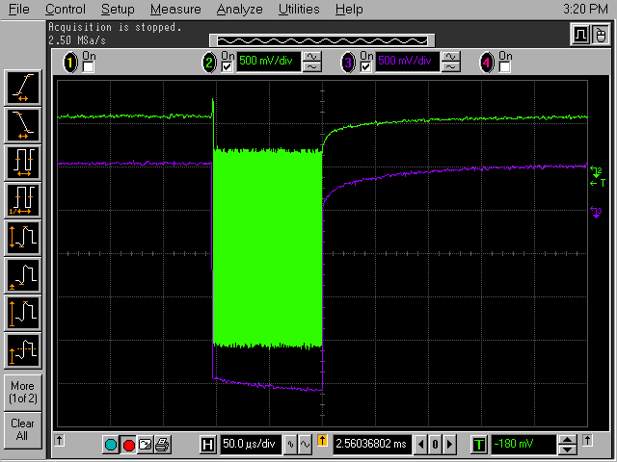
Figure 15 J32/J39 (CKB/HOLDB) - 1

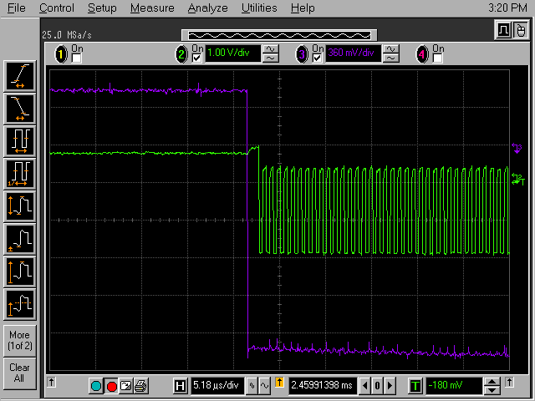
Figure 16 J32/J39 (CKB/HOLDB) - 2

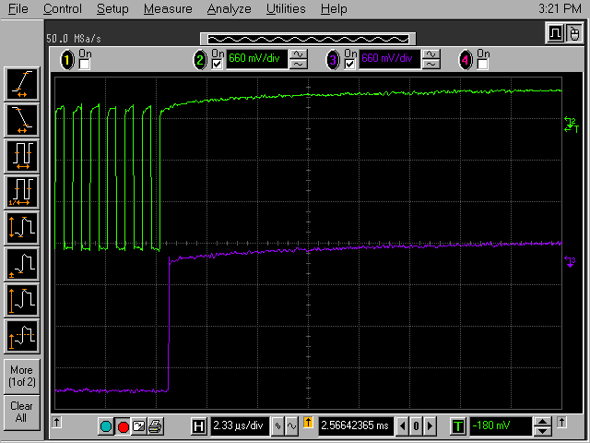
Figure 17 J32/J39 (CKB/HOLDB) - 3

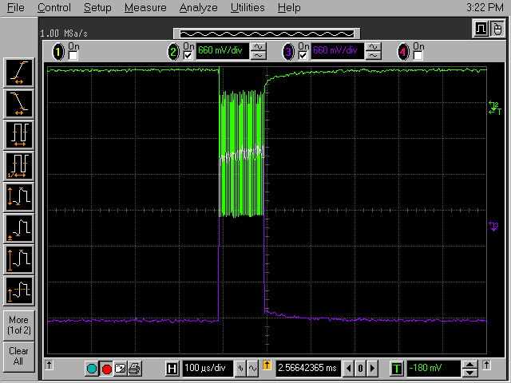
Figure 18 J32/U30P14 (CKB/SHIFTOUTB) - 1

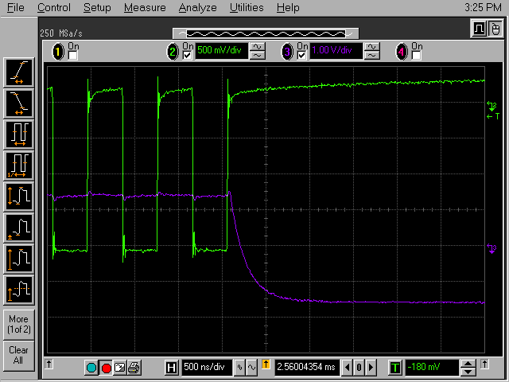
Figure 19 J32/U30P14 (CKB/SHIFTOUTB) - 2

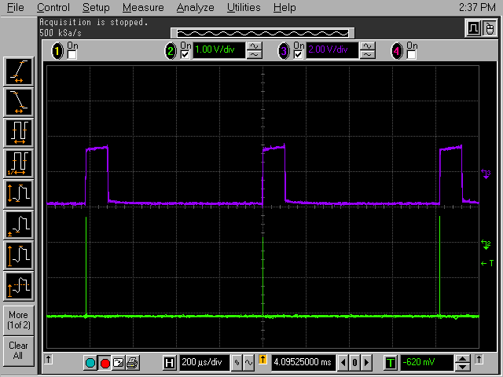
Figure 20 J34/U30P14 (SHIFTIN/SHIFTOUTB) - 1

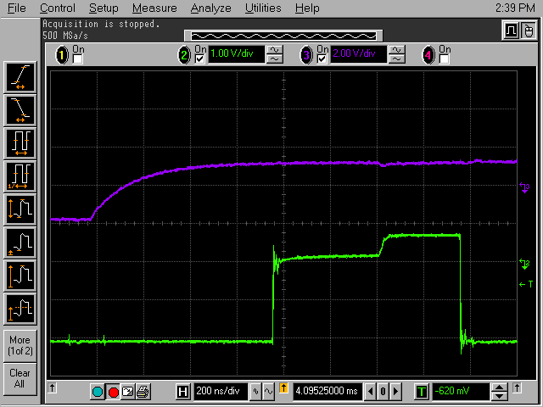
Figure 21 J34/U30P14 (SHIFTIN/SHIFTOUTB) - 2

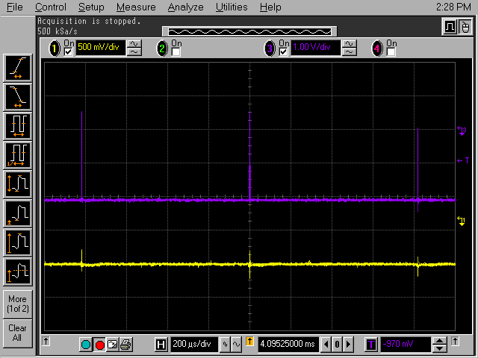
Figure 22 J34(SHIFTIN) /ANALOG OUT LEMO – 1

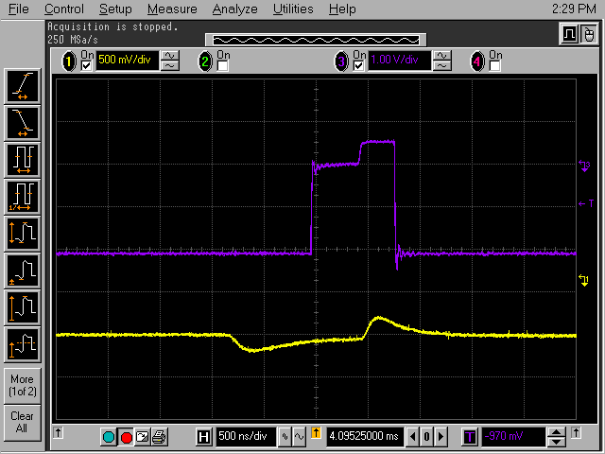
Figure 23 J34(SHIFTIN) /ANALOG OUT LEMO – 2

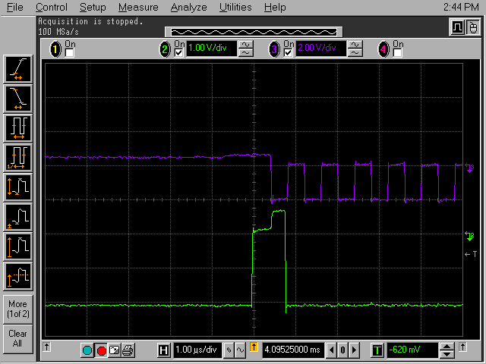
Figure 24 J34/J32 (SHIFTIN/CKB) - 1

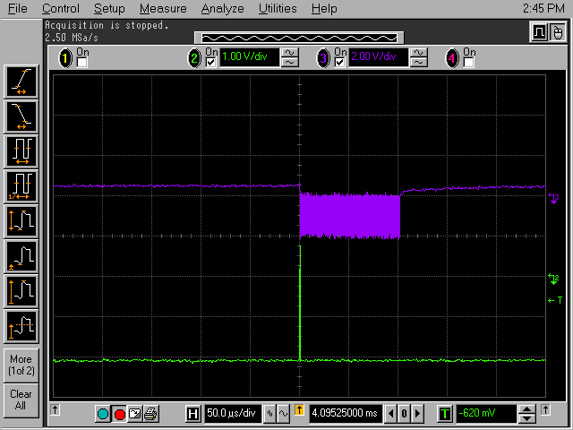
Figure 25 J34/J32 (SHIFTIN/CKB) - 2

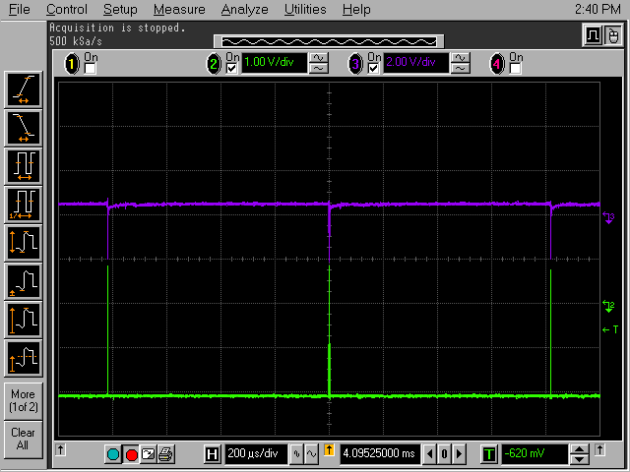
Figure 26 J34/J35 (SHIFTIN/SHIFTINB) - 1

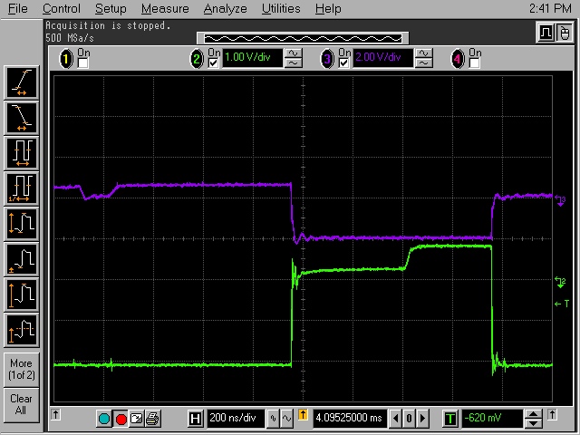
Figure 27 J34/J35 (SHIFTIN/SHIFTINB) - 2

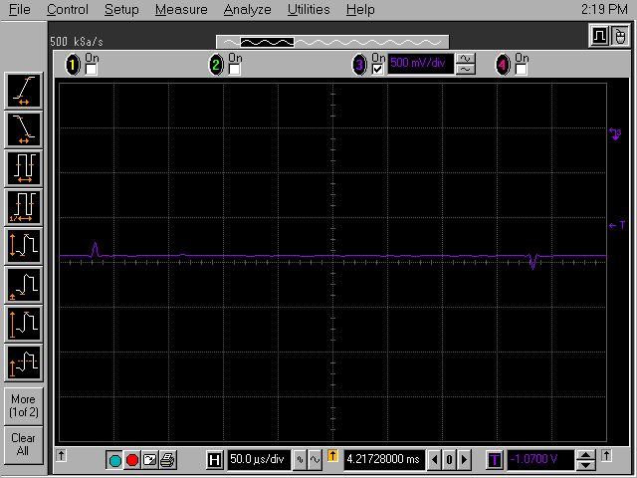
Figure 28 U30P2 (REGOUT)

