Download asic mask waveforms.

These waveforms are all taken at test points within the VATAC, using VATAC firmware to download the asic mask pattern.

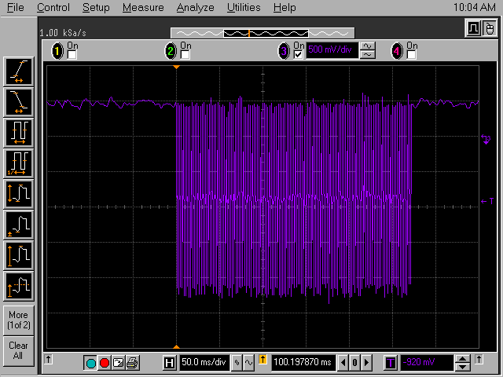
Figure 1 J44 (CLKIN)

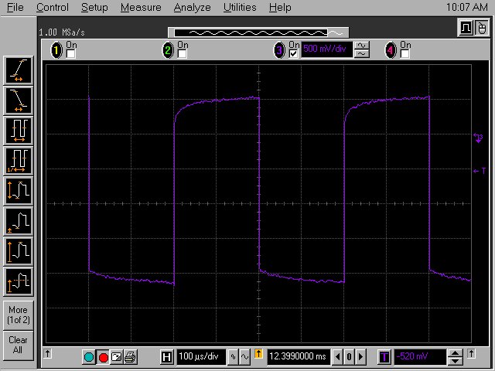
Figure 2 J44 (CLKIN)

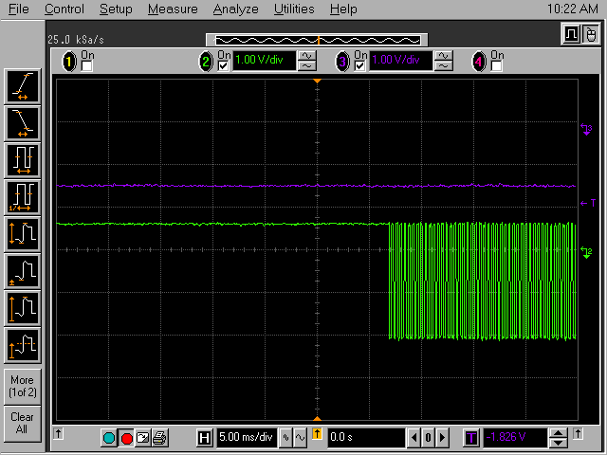
Figure 3 J44 - U30P2 (CLKIN REGOUT)

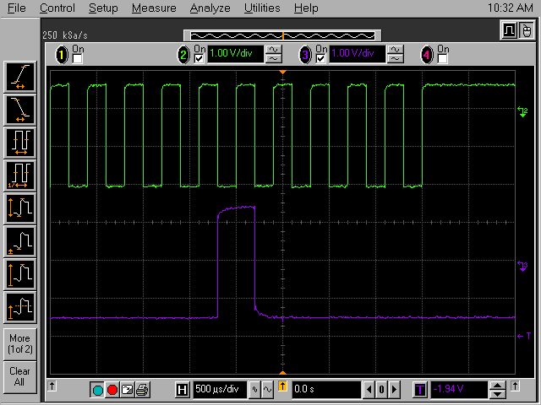
Figure 4 J44 - U30P2 (CLKIN REGOUT)

The regin/regout signals are the “data” for the bit mask. Seems strange there is a regout signal when we only have one asic in the chain. Also in fig 7 we can see that the regin signal changes several times before clkin is applied. Perhaps it was desirable to avoid writing the dac patterns for a bitmasks download, but with looking at the serial control register mask pattern from the va1ta spec I am puzzled how this has achieved this.

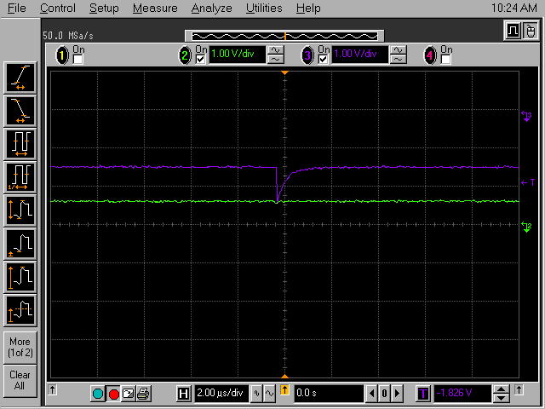
Figure 5 J44 - U30P2 (CLKIN REGOUT)
This is a glitch. No further identification made at present.

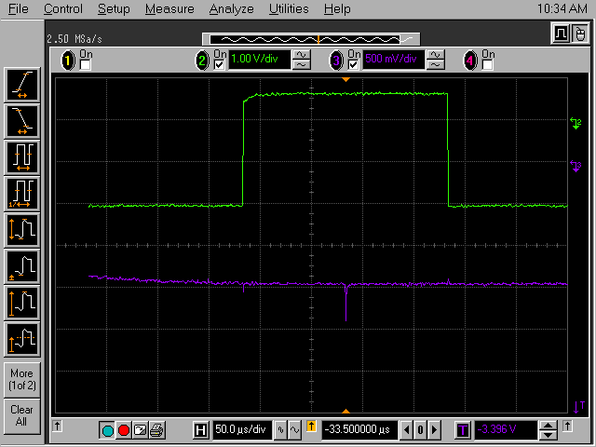
Figure 6 J44 - U30P2 (CLKIN REGOUT) – Another picture of the glitch.

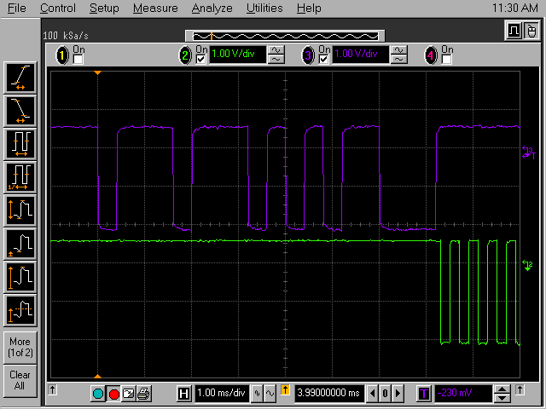
Figure 7 J44 – J45 (CLKIN REGIN) – regin changing before the clkin signal.

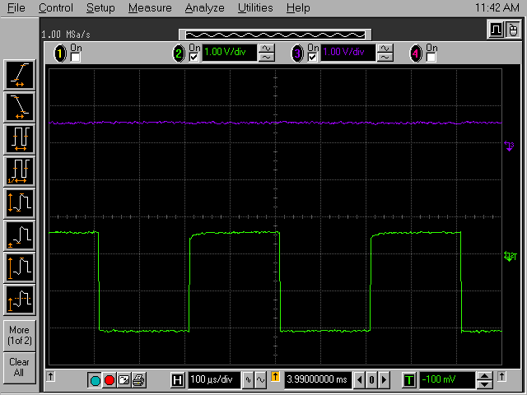
Figure 8 J44 – J36 (CLKIN DRESETB) – dreset resets the logic part of the chip. No activity with mask download. Perhaps it is used more for the analog output multiplexer.

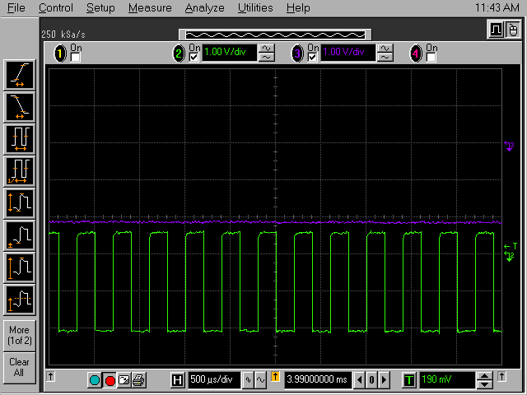
Figure 9 J44 – J37 (CLKIN DRESET). No activity.

ShiftinB, Shiftin and ShiftoutB have no activity during this download.

